

NAME: NATASHA WANJIRU THUNGU.
ADM NO: BSCCS/2024/53895.

UNIT CODE: BIT3208.
UNIT: ADVANCED WEB DESIGN AND DEVELOPMENT.
DEPARTMENT: COMPUTING AND INFORMATICS.

LECTURER: MR. NYORO.
YEAR, SEM: 2026, May/Aug.

DECLARATION.
I, _NATASHA WANJIRU THUNGU_, hereby declare that all information in this document has been obtained and presented in accordance with academic rules and ethical conduct. Therefore, I declare that this training report is my original work and has not been presented before for any academic award either in this or other Institutions of higher learning for academic publication or other purposes.

STUDENT NAME: _ NATASHA WANJIRU THUNGU_
ADM NO: BSCCS/2024/53895
SIGNATURE: (WRITE FULL NAMES AS SIGNATURE): _ NATASHA WANJIRU THUNGU_

GITHUB REPOSITORY: https://github.com/natashanats170-sudo/Advanced-Web-Design

TABLE OF CONTENTS.
WEEK 1: Environment Setup. 3
Step 1: Install Localhost Tools. 3
Step 2: Test Localhost Successfully. 3
Step 3: Create Hello World Pages. 4
Step 4: Test Basic Database Connectivity. 5
WEEK 2: Wireframes, GUI Design and Project Planning. 6
Step 1: Design Wireframes. 6
Step 2: Design GUI Layouts. 9
WEEK THREE: JavaScript Basics, Form Validation, and PHP Introduction. 10
Step 1: Implement JavaScript Basics. 10
Step 2: Create Form Validation. 11
Step 3: Practice DOM Manipulation. 11
Step 4: Test PHP Syntax. 13
Step 5: Practice Basic Database Connection. 13
WEEK 4: Server-Side Components and Backend Development. 13
Task 1: Simple PHP Processing Page. 13
Task 2: HTML Forms and PHP Integration. 14
Task 3 Answer – Simple Authentication System. 16
Task 4: Backend Folder Organization. 17
WEEK 5: Databases and CRUD Operations. 24
Task 1: Database Creation. 24
Task 2: Creating Tables. 24

WEEK 1: Environment Setup.
The goal of Week 1 was to set up a local development environment (localhost) so PHP scripts and databases can be tested on your own computer without internet hosting.

Step 1: Install Localhost Tools.
Figure 1.1: Shows that xampp installed.
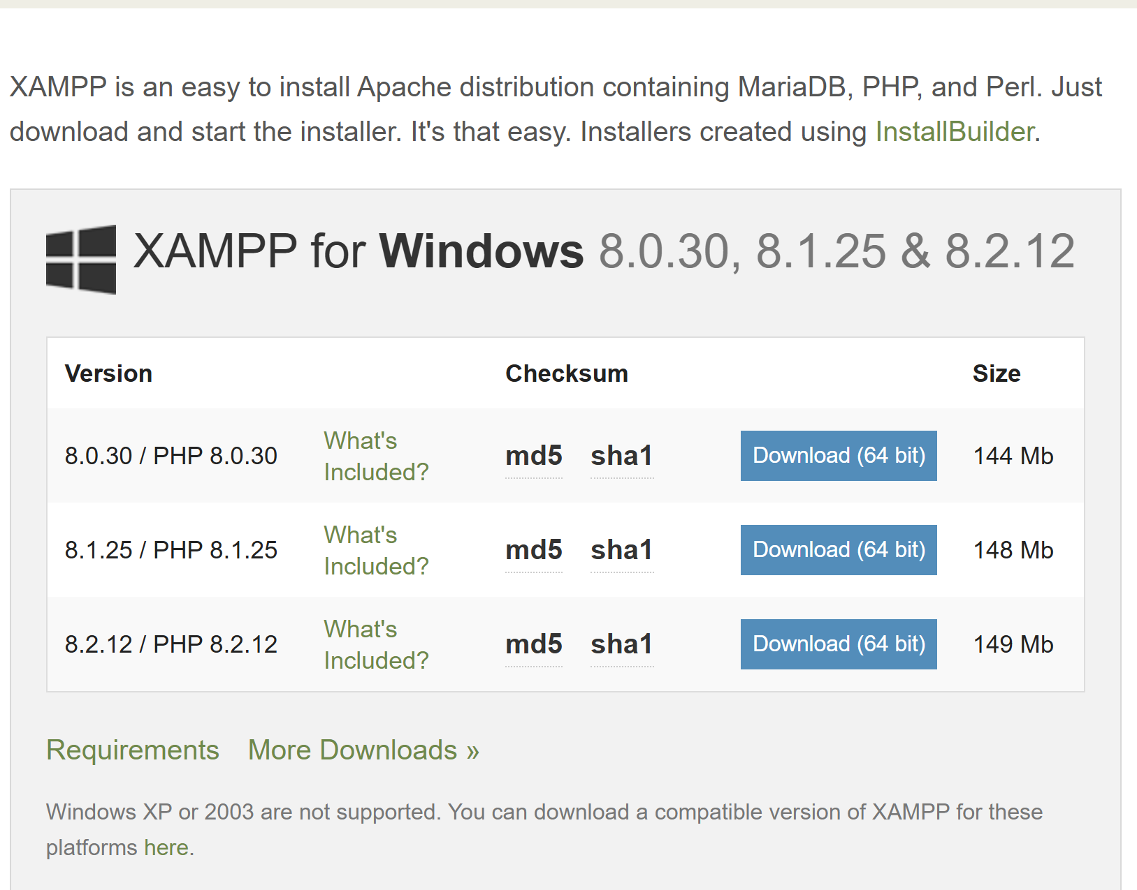

Step 2: Test Localhost Successfully.
Figure 1.2: Shows that xampp is successfully installed.
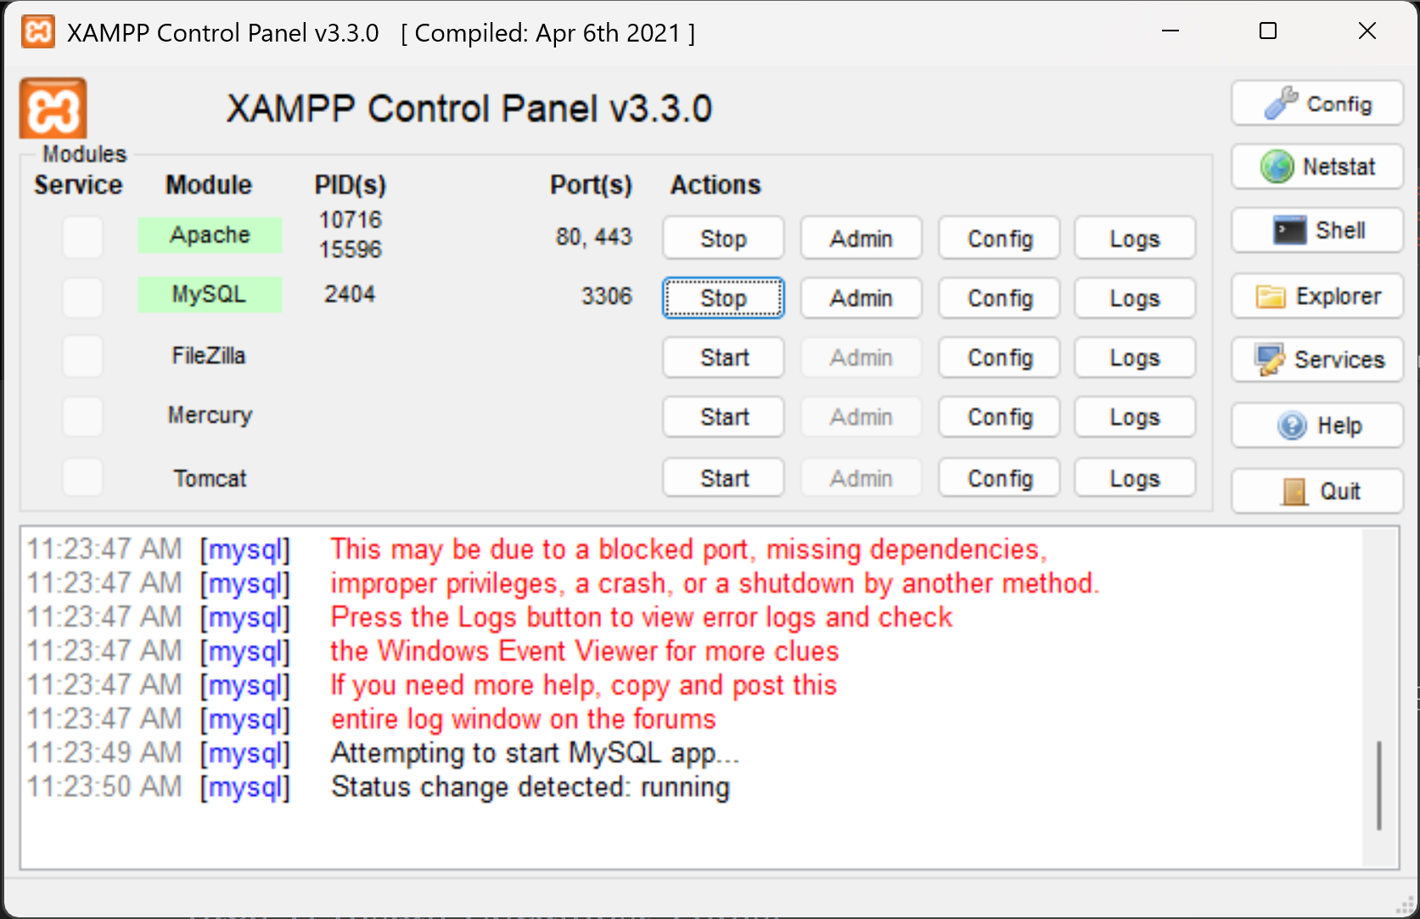

Figure 1.3: Shows that xampp is working successfully.
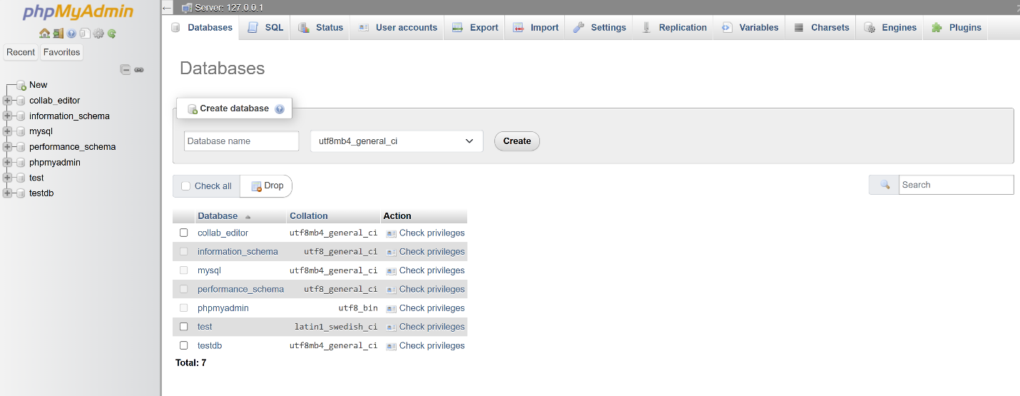

Step 3: Create Hello World Pages.
Figure 1.4: Shows the Hello World page created with php.
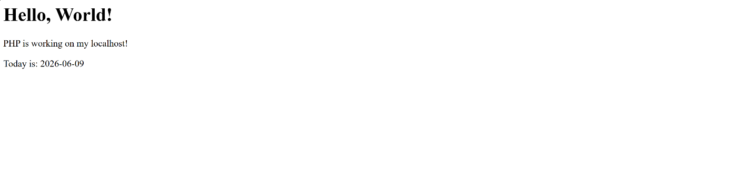

Figure 1.5: Shows the Hello World page created with html.
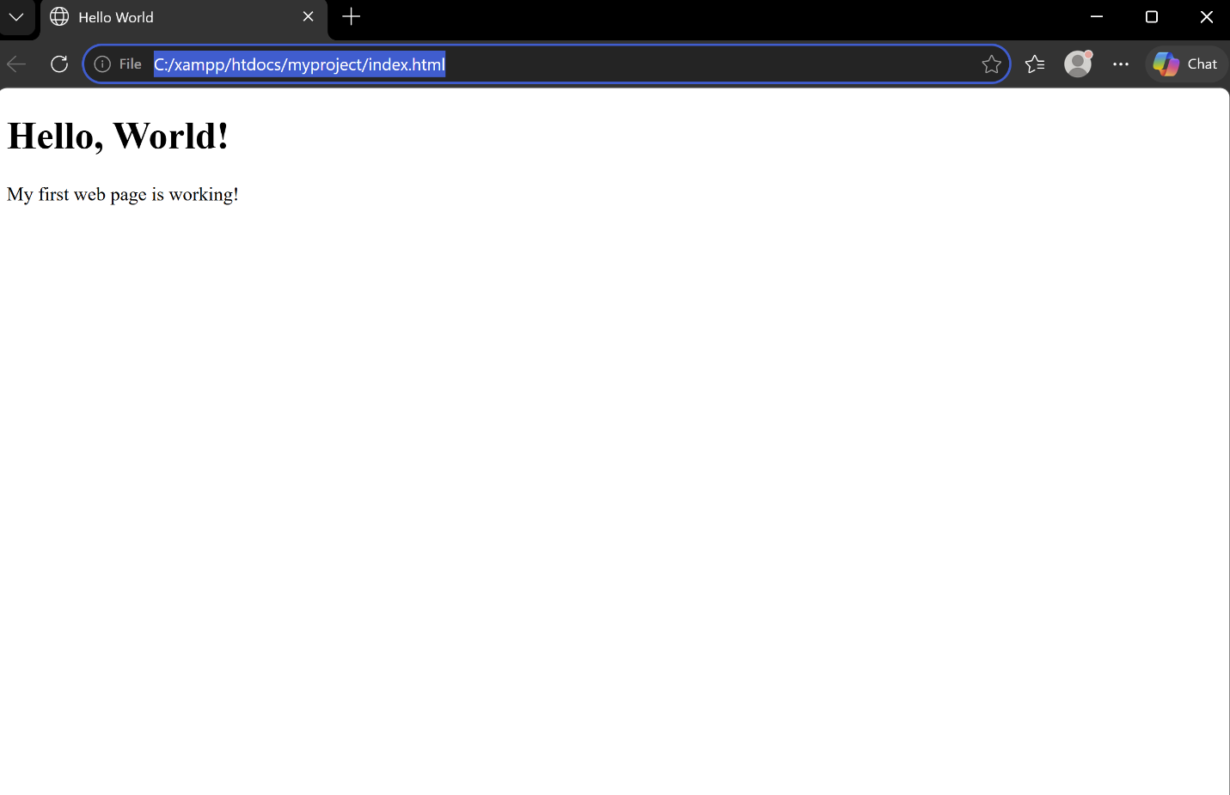

Step 4: Test Basic Database Connectivity.
Figure 1.6: Shows the basic database connectivity.
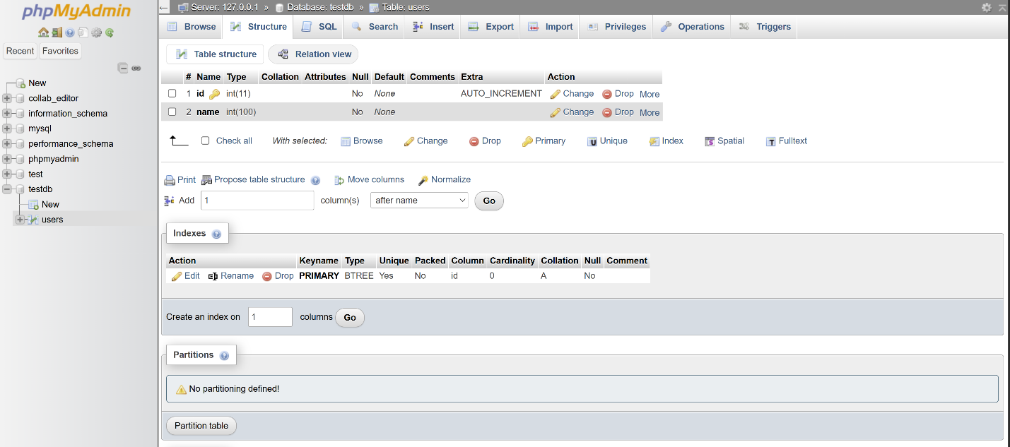
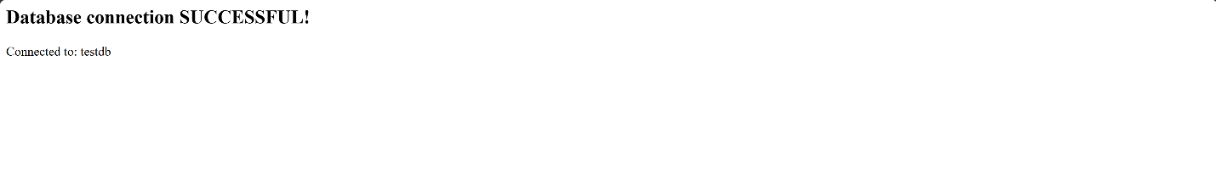

WEEK 2: Wireframes, GUI Design and Project Planning.
Week 2 focuses on planning your project before writing any code. This is an important professional habit — developers always plan the layout and flow before building.

Step 1: Design Wireframes.
Figure 2.1: Shows the first page ( Homepage ) of the wireframe.
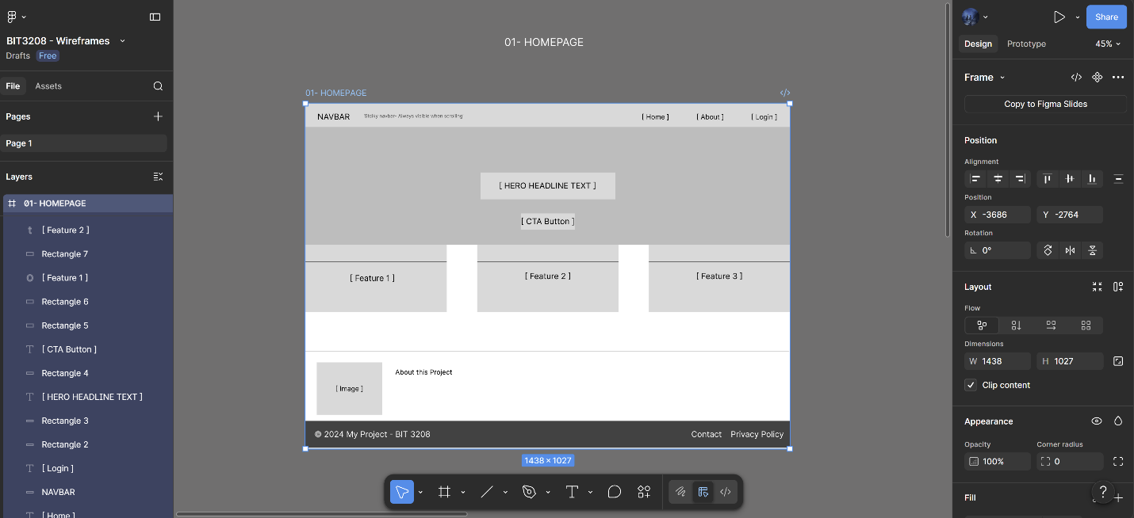
Figure 2.2: Shows the second page( login page ) of the wireframe.
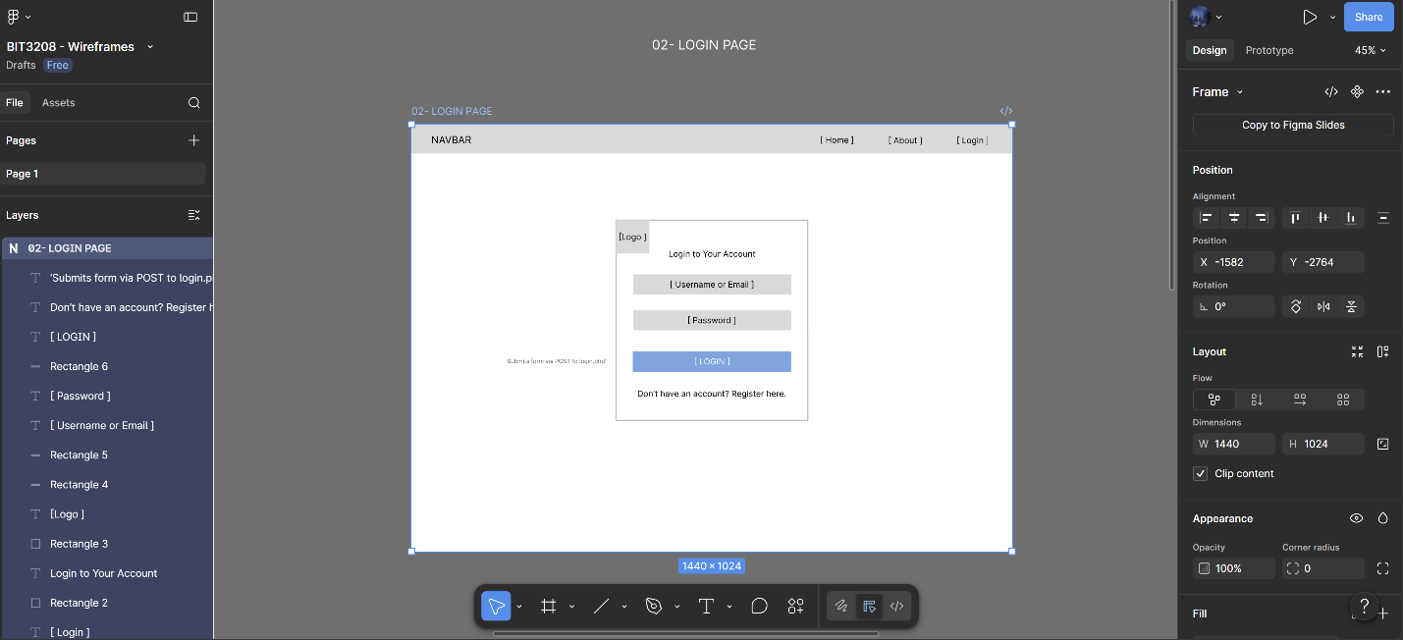
Figure 2.3: Shows the third page ( Registration page ) of the wireframe.
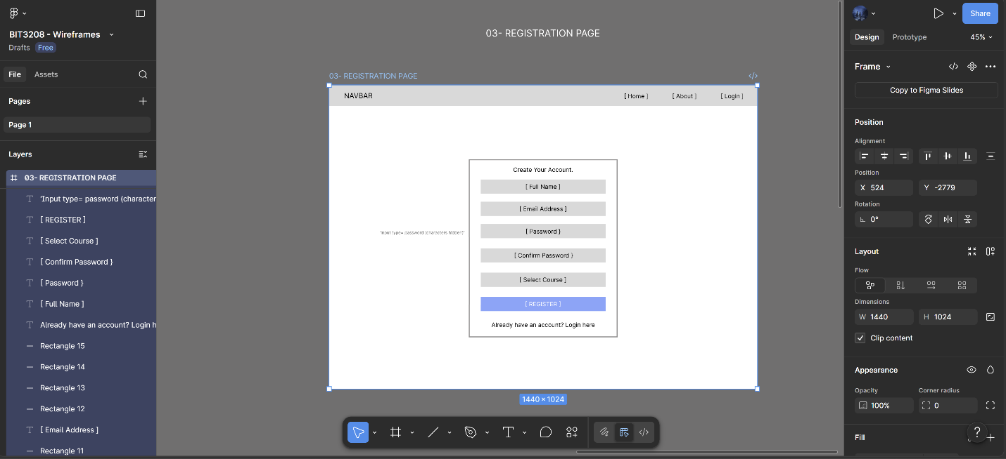
Figure 2.4: Shows the fourth page ( Dashboard ) of the wireframe.
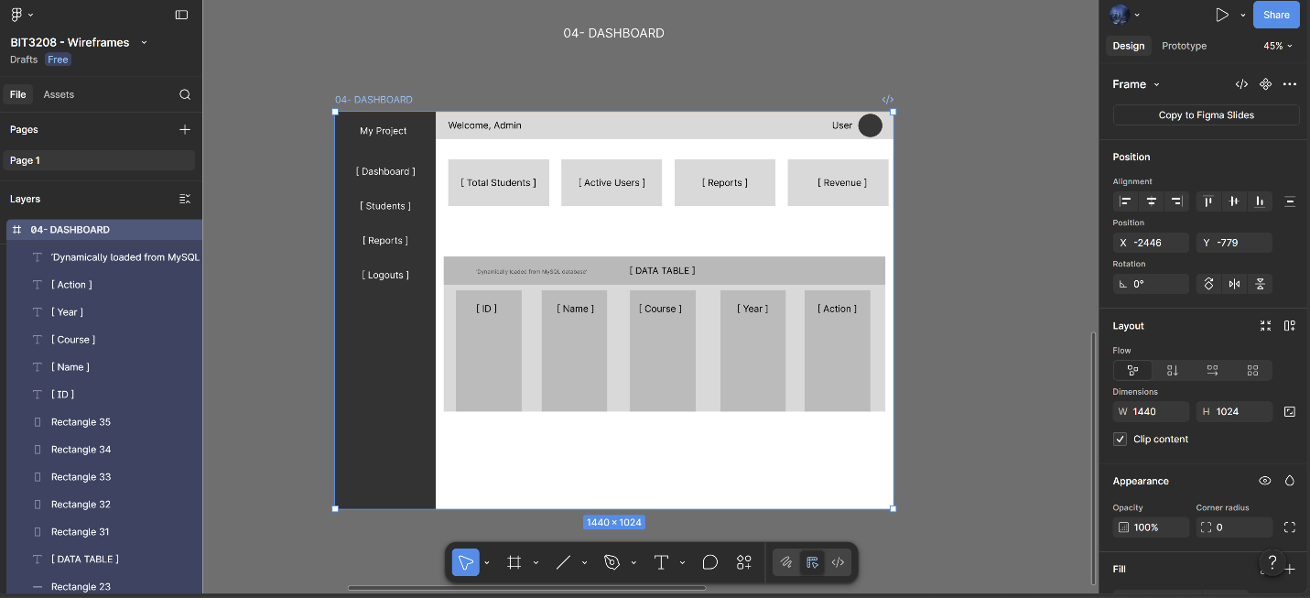
Figure 2.5: Shows the fifth page ( Contact Page ) of the wireframe.
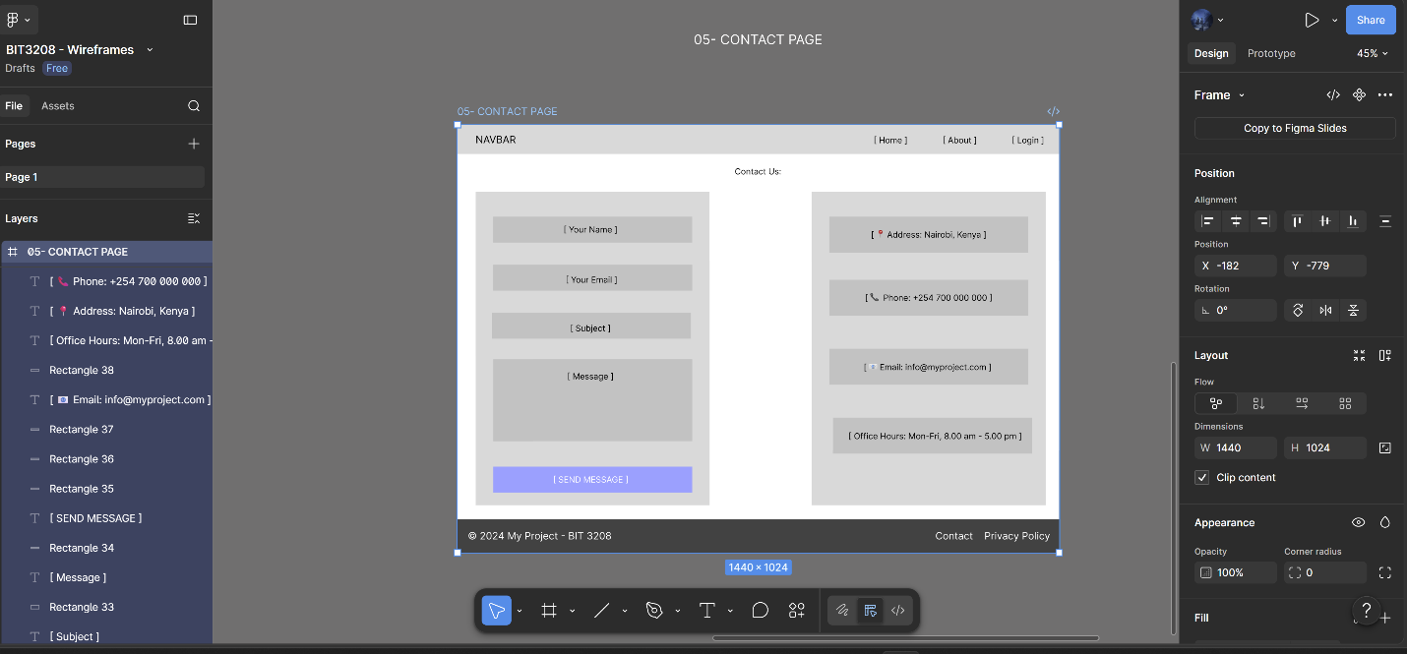

Step 2: Design GUI Layouts.
Figure 2.6: Shows the output in a browser.
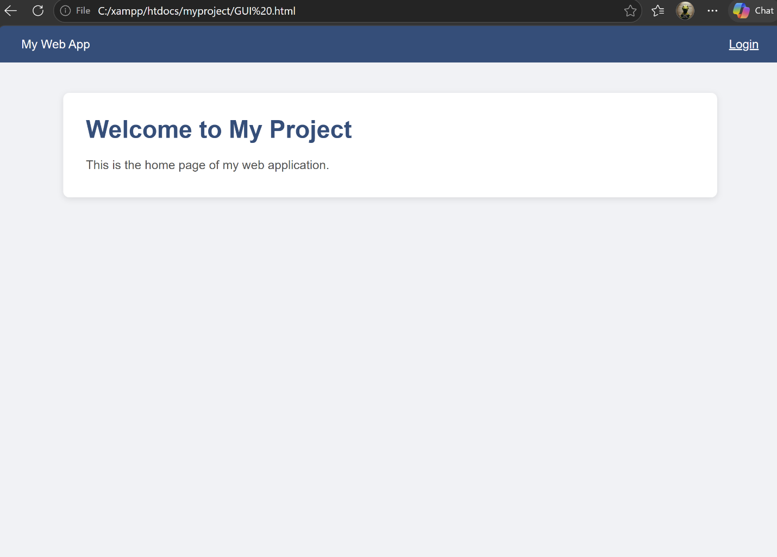

WEEK THREE: JavaScript Basics, Form Validation, and PHP Introduction.

Step 1: Implement JavaScript Basics.
Figure 3.1: Shows the outputs of the JavaScript concept for Variables.
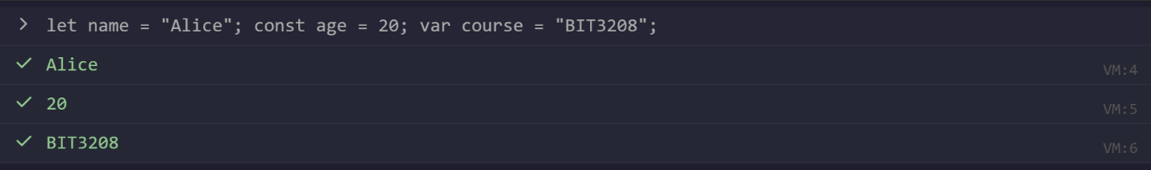
Figure 3.2: Shows the outputs of the JavaScript concept for Functions.
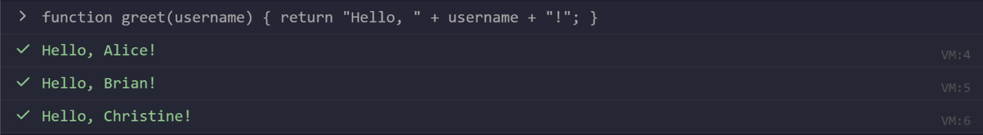
Figure 3.3: Shows the outputs of the JavaScript concept for If/Else.
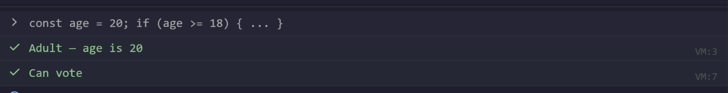
Figure 3.4: Shows the outputs of the JavaScript concept for Loops.
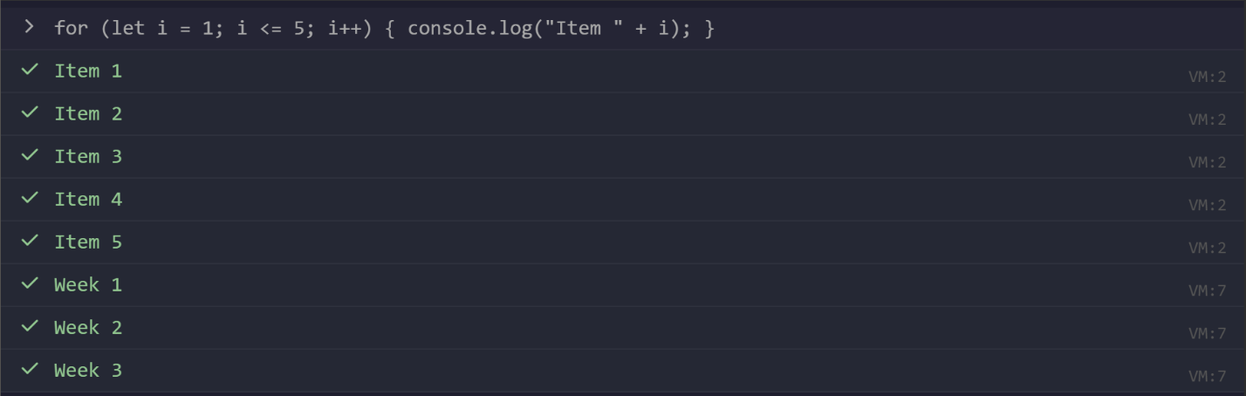
Figure 3.5: Shows the outputs of the JavaScript concept for Arrays.
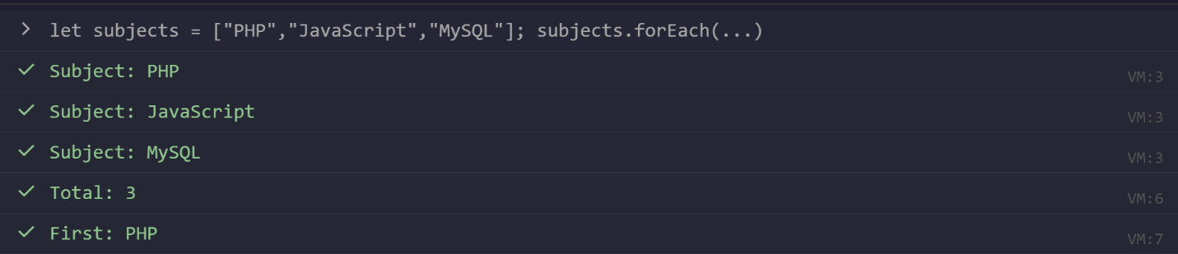

Step 2: Create Form Validation.
Figure 3.6: Shows the submit form with empty fields.
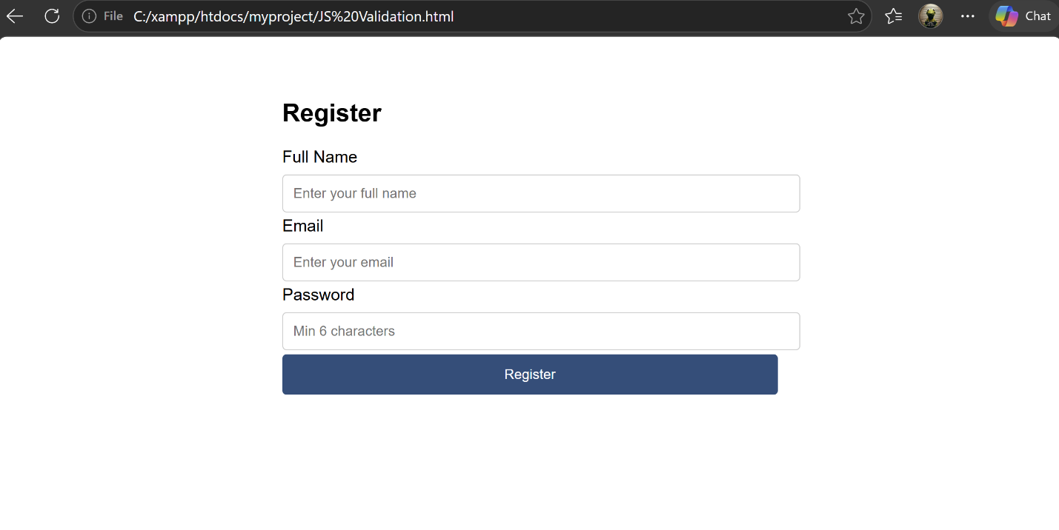

Step 3: Practice DOM Manipulation.
Figure 3.7: Shows the original page before the DOM changes.
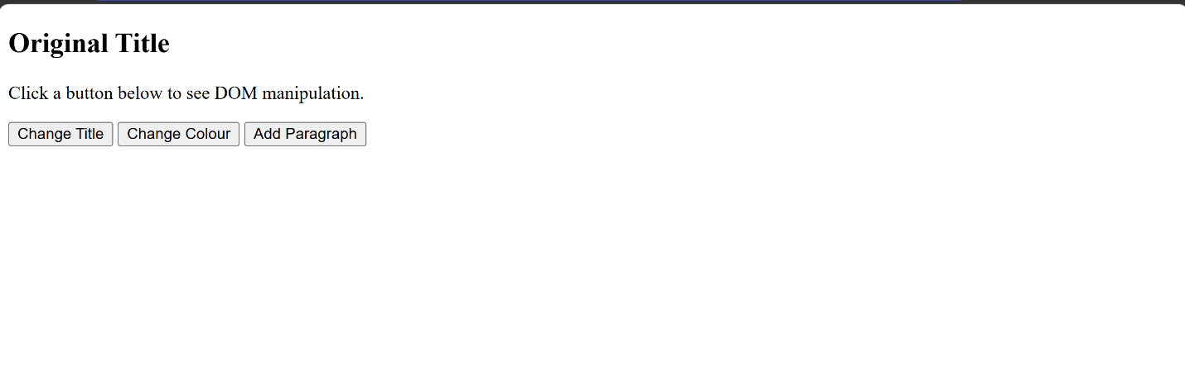
Figure 3.8: Shows the page after the DOM changes to the title.
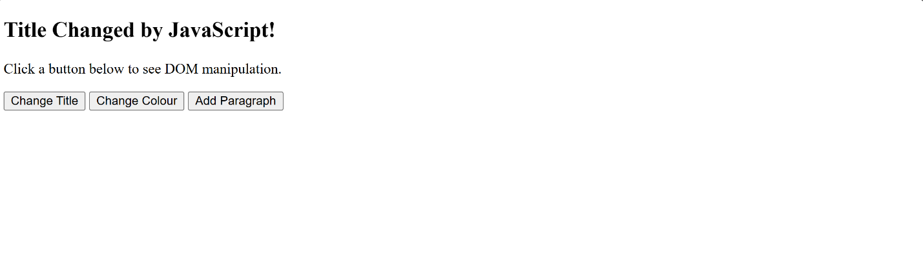
Figure 3.9: Shows the page after the DOM changes to the second titles color.
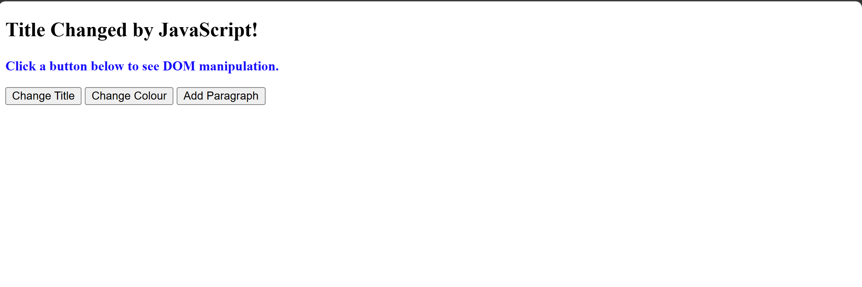
Figure 3.10: Shows the page after the DOM adds a paragraph.
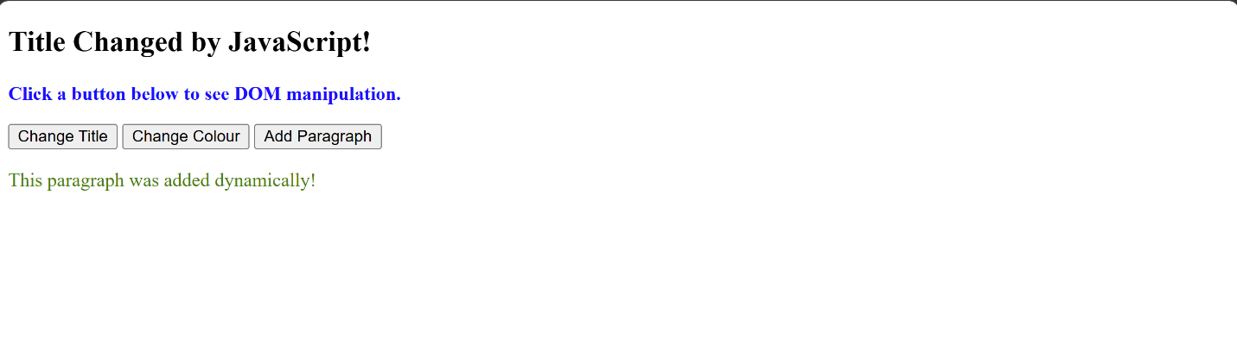

Step 4: Test PHP Syntax.
Figure 3.11: Shows the browser output from the php concepts.
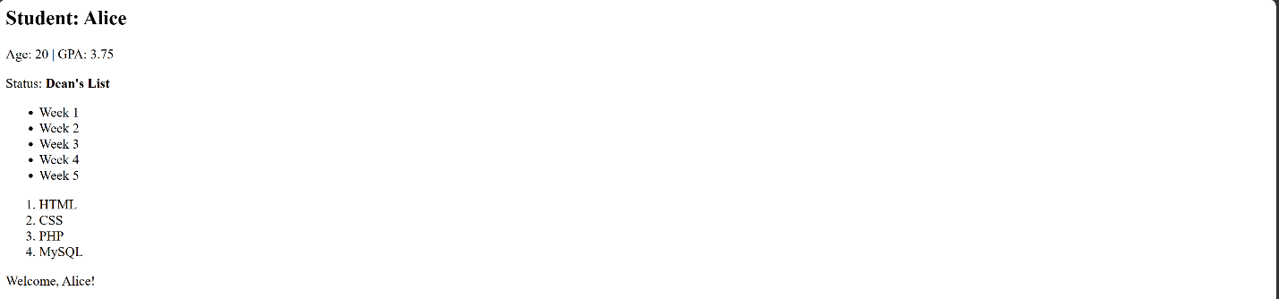

Step 5: Practice Basic Database Connection.
Figure 3.12: Shows that connections was successful in database connectivity re-test.
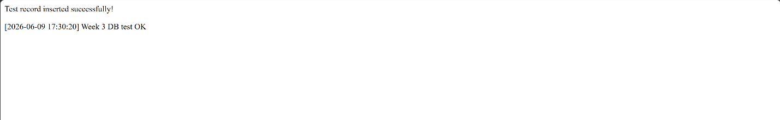

WEEK 4: Server-Side Components and Backend Development.

Task 1: Simple PHP Processing Page.
Figure 4.1: Shows the code for the html.
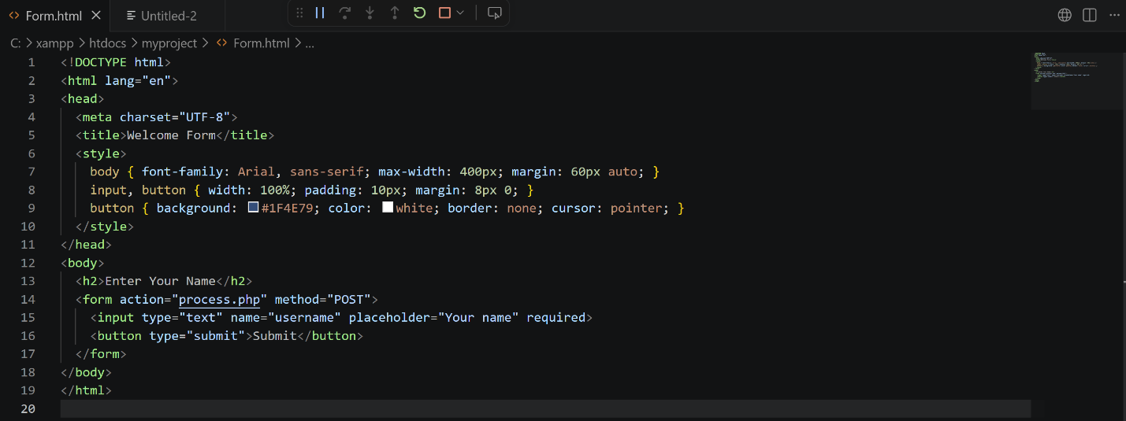
Figure 4.2: Shows the output for the page.
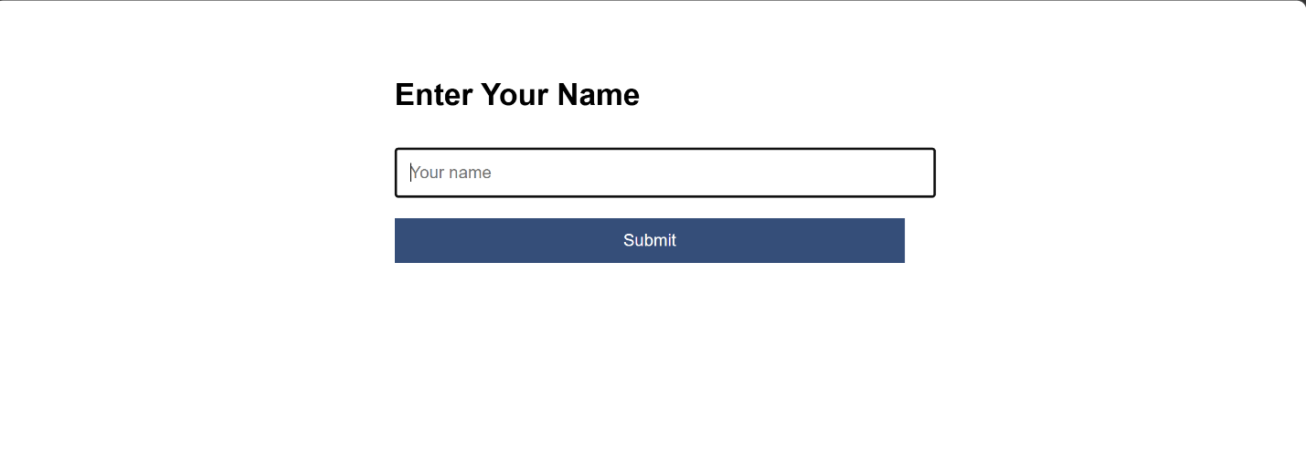
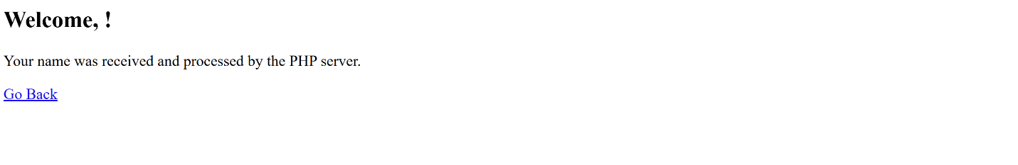

Task 2: HTML Forms and PHP Integration.
Figure 4.3: Shows the code used.
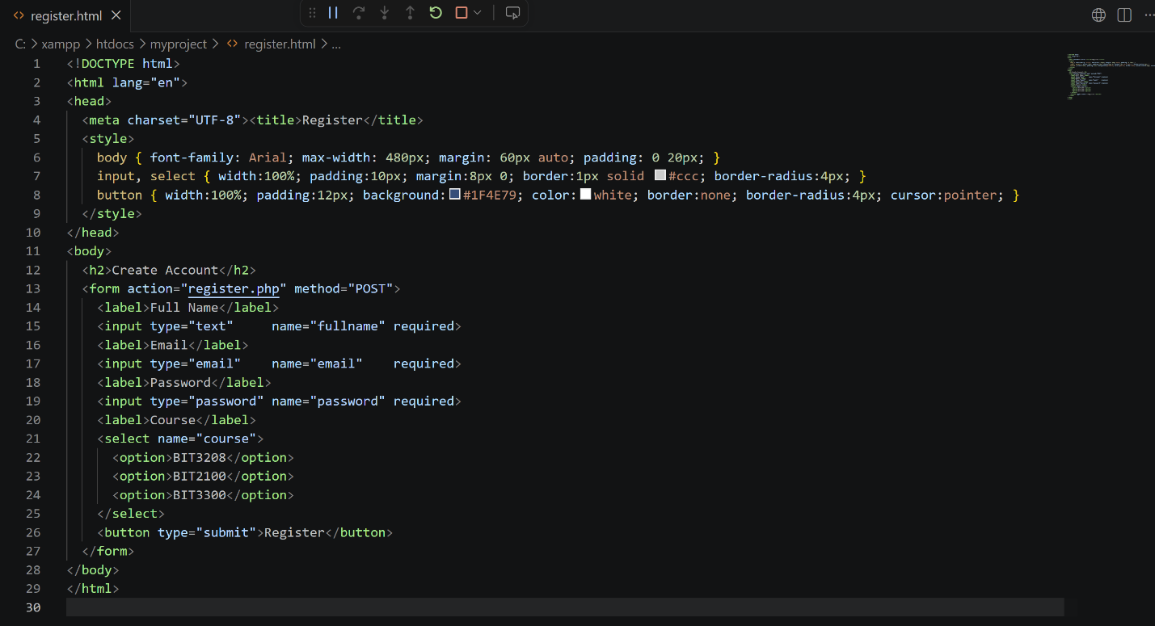
Figure 4.4: Shows the registration page before and the output if successful or not.
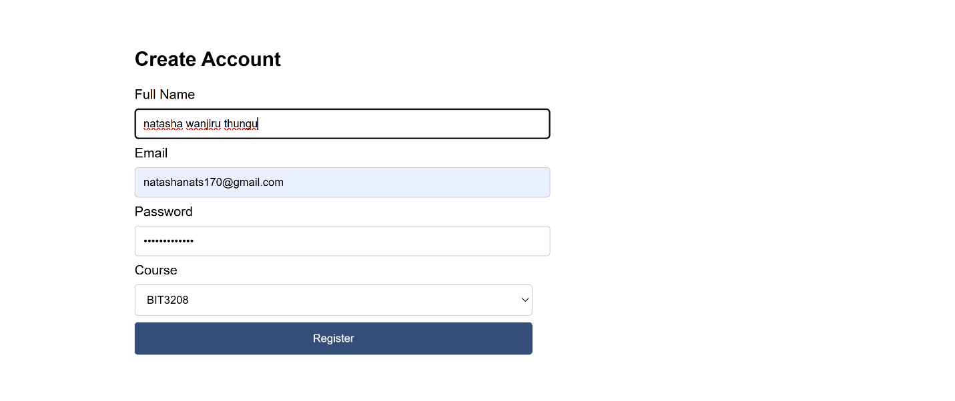
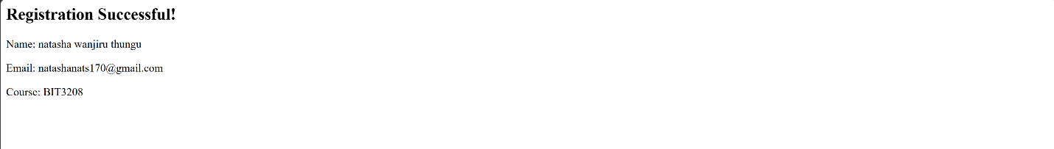
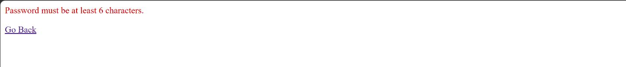

Task 3 Answer – Simple Authentication System.
Figure 4.5: Shows the login form.
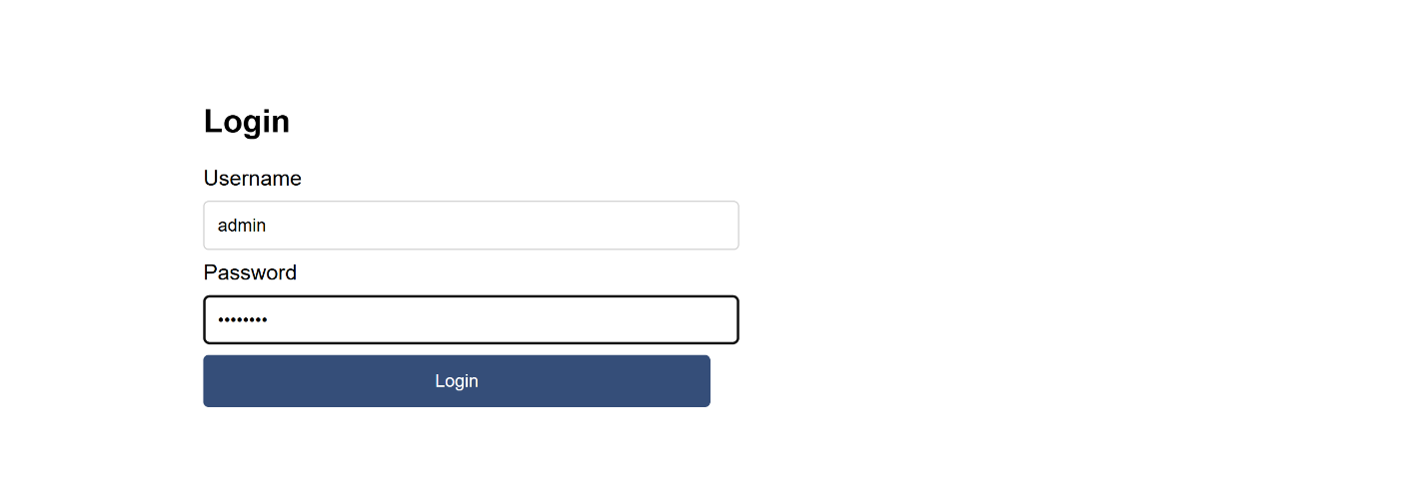
Figure 4.6: Shows the error for wrong credentials.
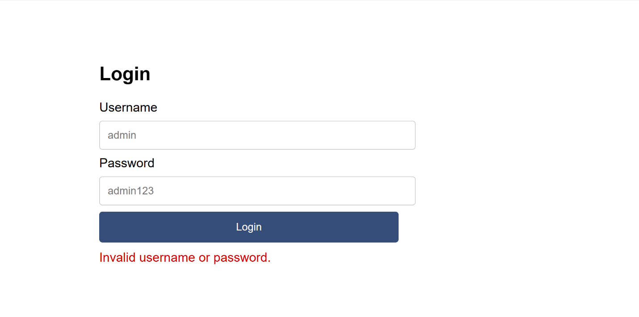
Figure 4.7: Shows the dashboard and logout redirecting back to login.


Task 4: Backend Folder Organization.
Figure 4.8: Shows the project folder in the main xampp folder.
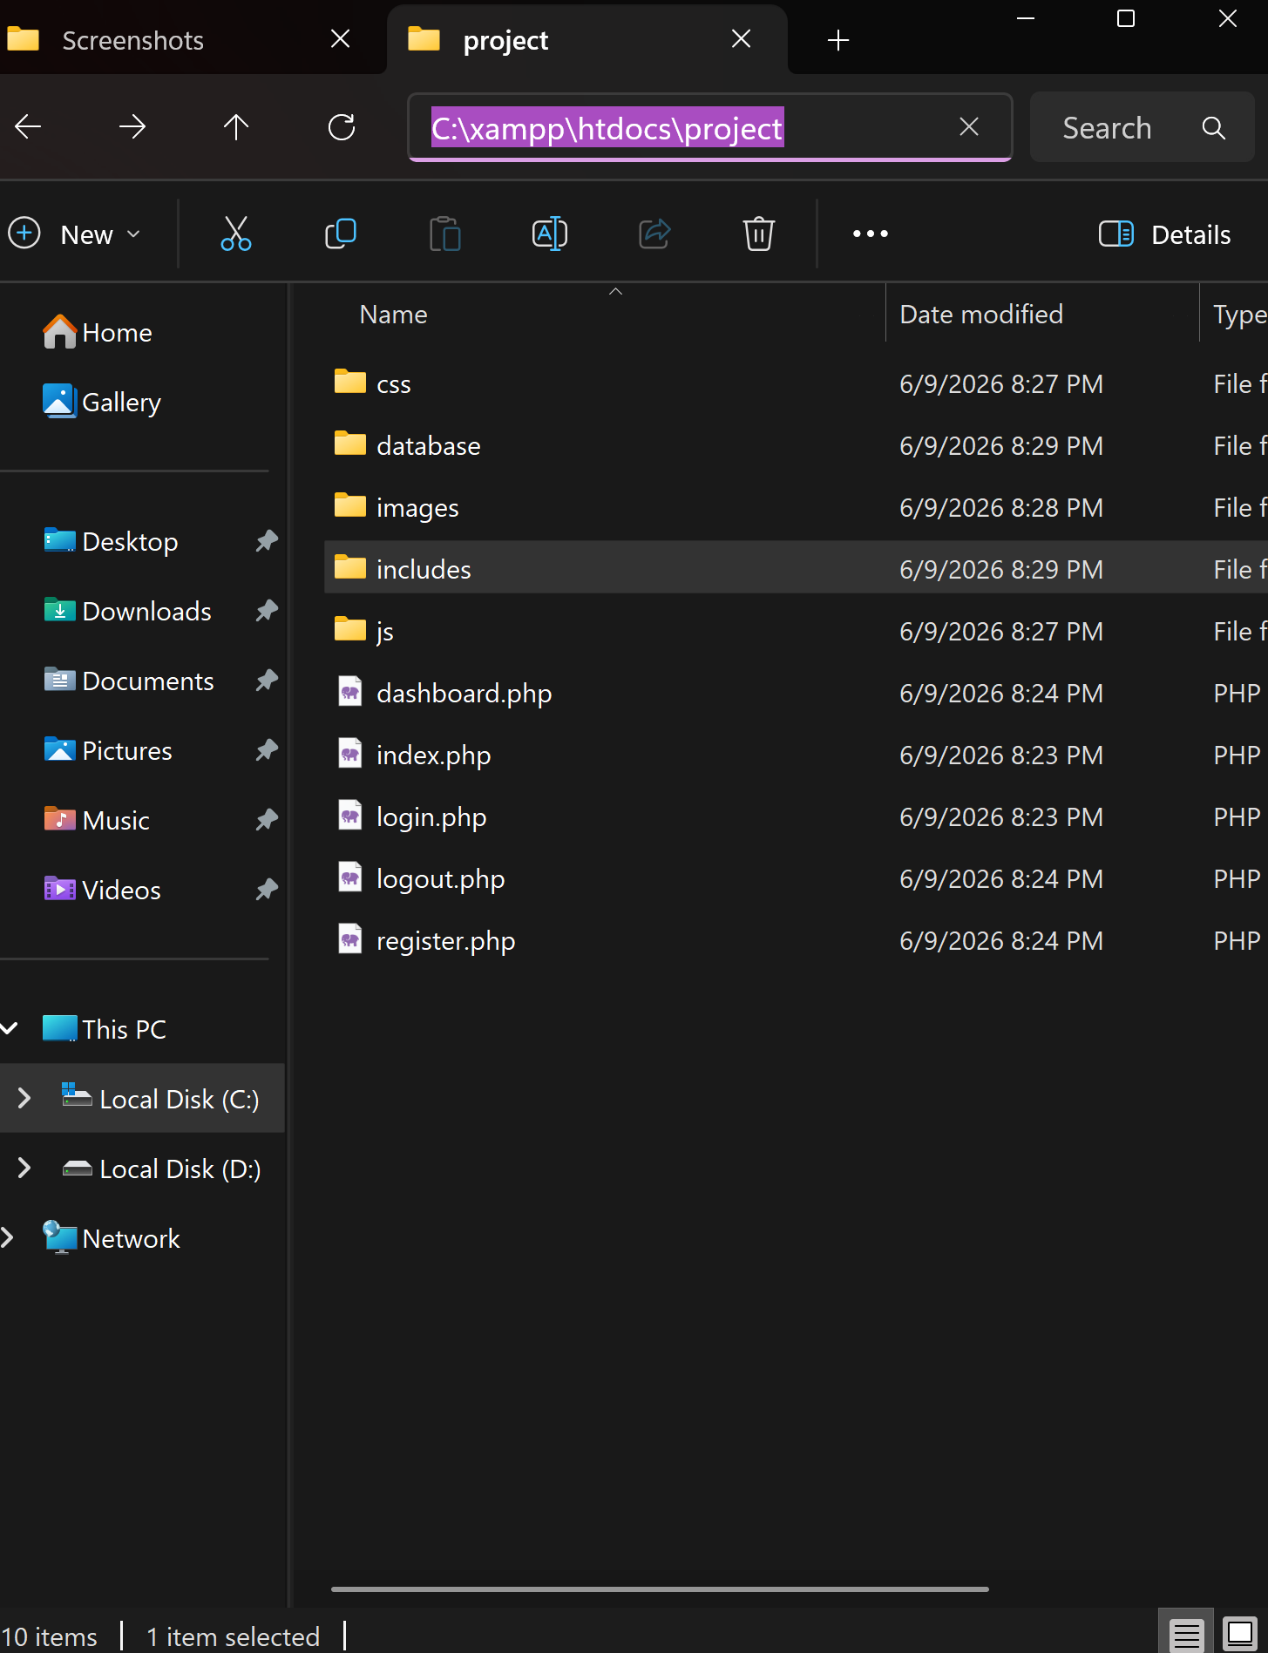
Figure 4.9: Shows the subfolders in the main project.
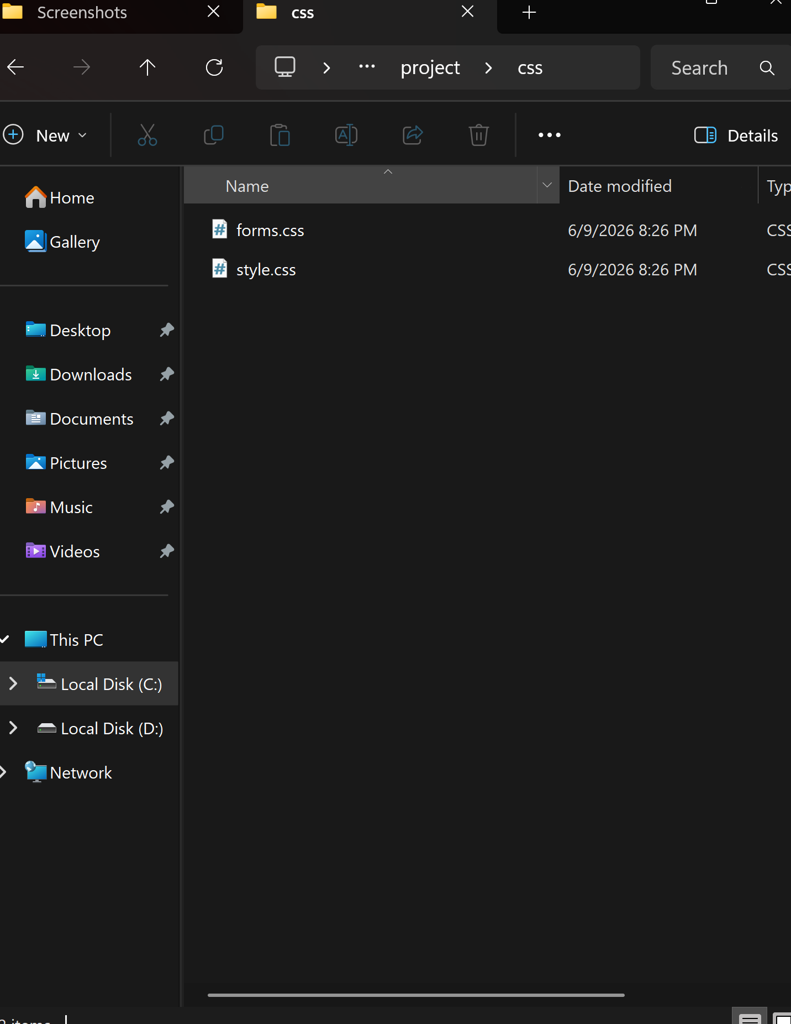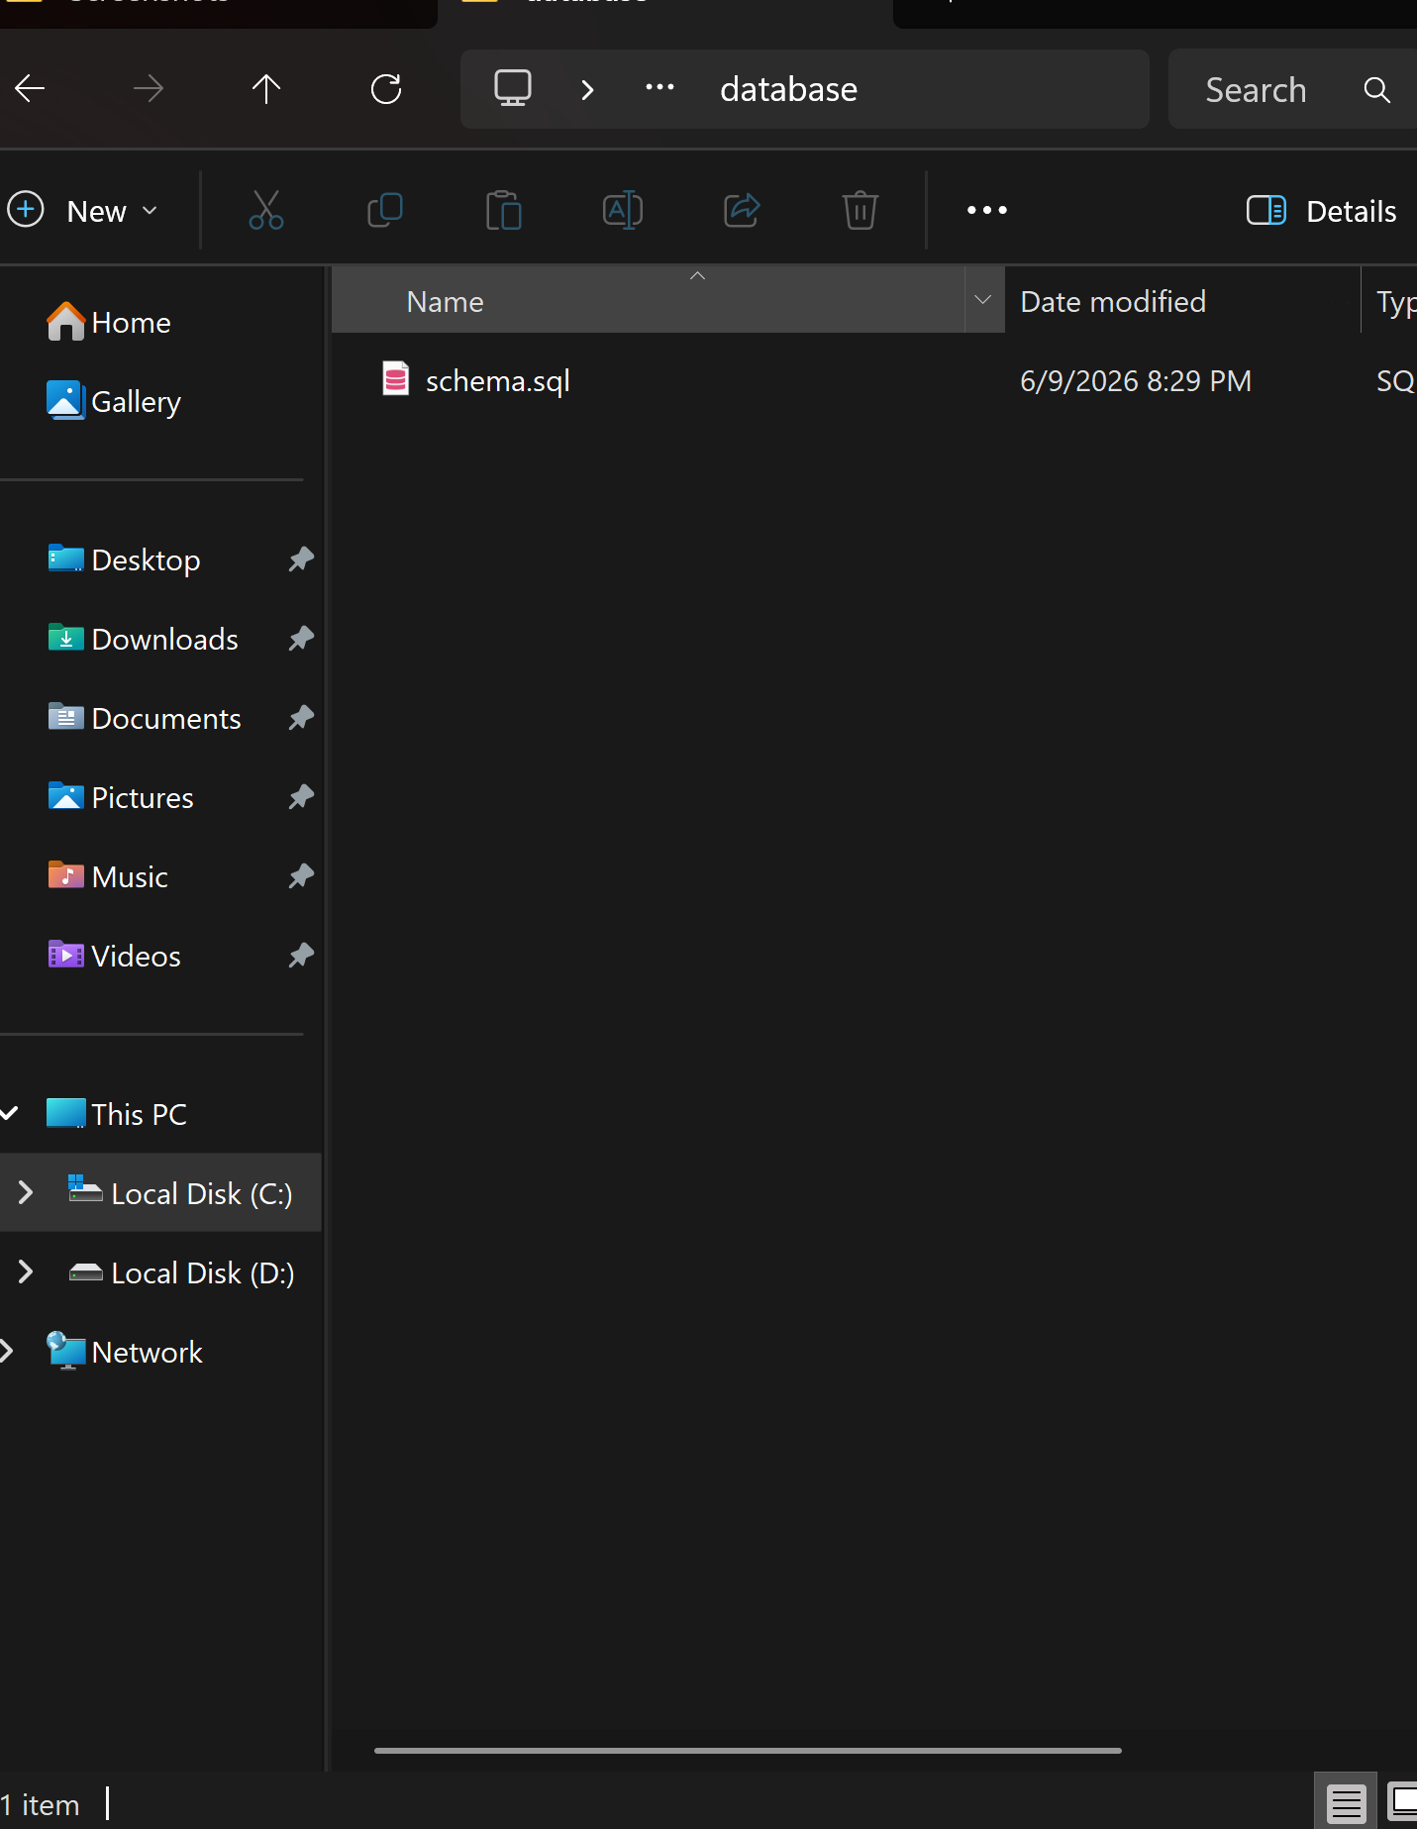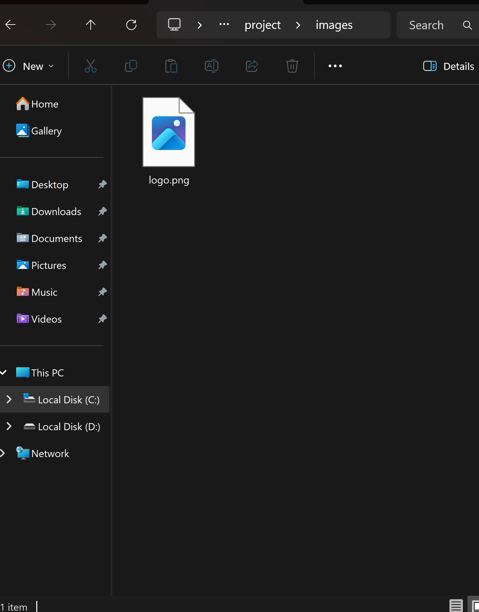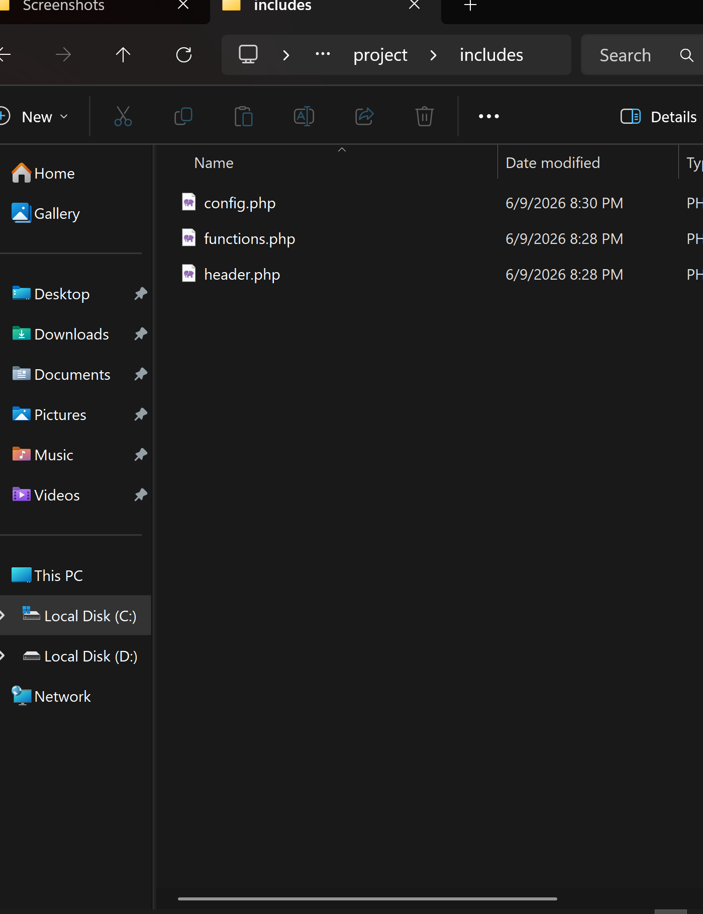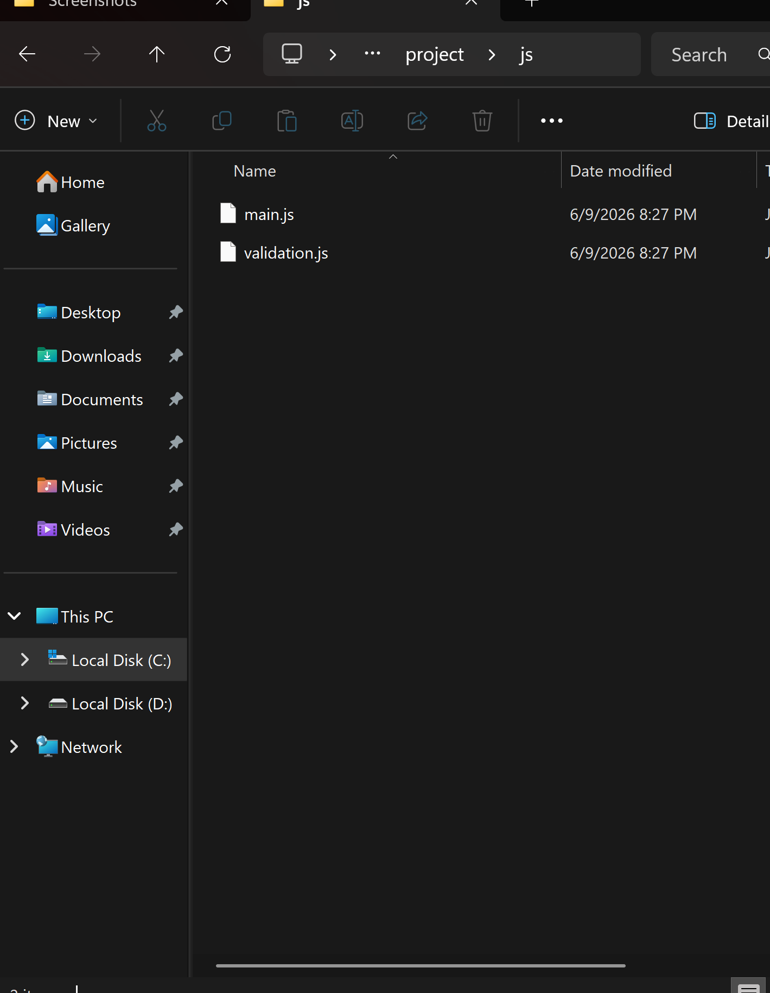

WEEK 5: Databases and CRUD Operations.

Task 1: Database Creation.
Figure 4.10: Shows the database created on phpMyAdmin.
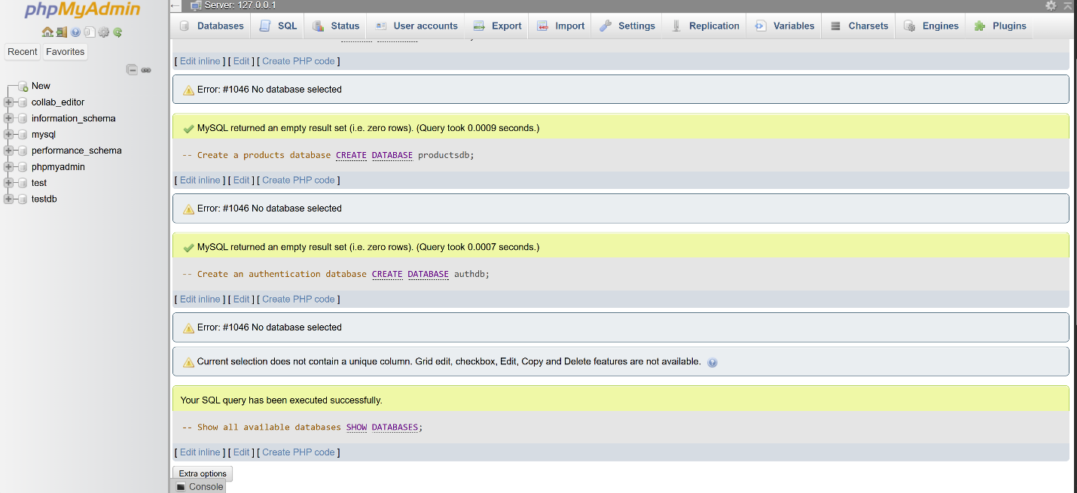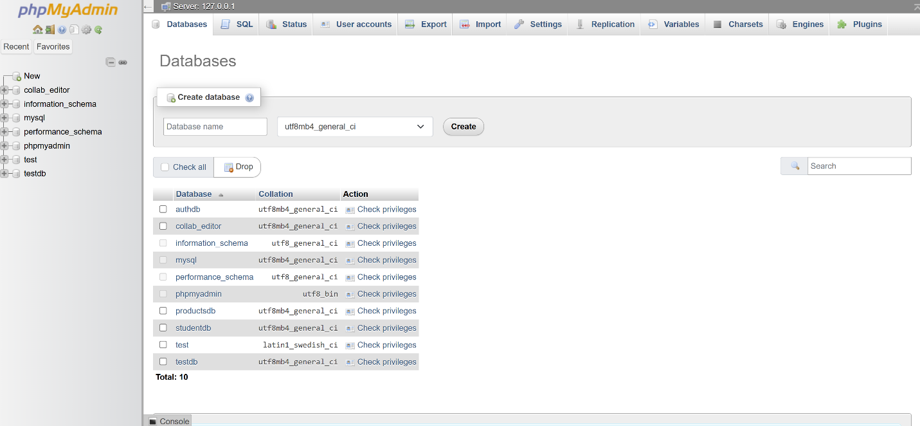

Task 2: Creating Tables.
Figure 4.11: Shows the tables created in phpMyAdmin.
